What do I need to know?
- Given a graph, identify the parent function.
- Given the equation of a function, know what the graph looks like
- Given an equation, be able to identify the domain, range, and x and y intercepts (if present).
- State the symmetry of the graph of the function. Is it even (y-axis symmetry) or odd (origin symmetry)?
- Given a real-world scenario, be able to state independent and dependent variables
- Given a real-world scenario, be able to state a reasonable domain and range.
REVIEW PROBLEMS:
- Which one of the following is the square root parent function?
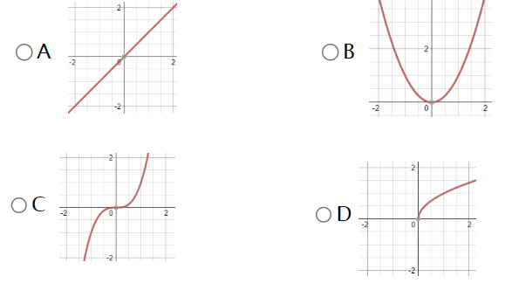

- Which one of the following is the quadratic parent function?
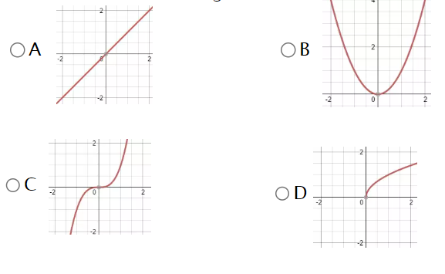

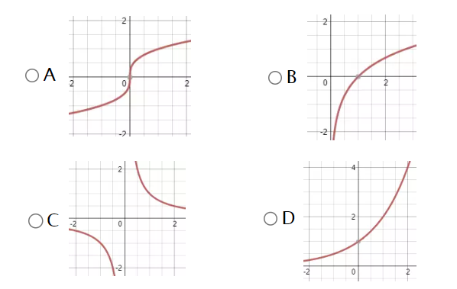
- Which of the following is the rational parent function?


- Which of the following is the exponential parent function?

- Which of the following is the cube root parent function?


ALL FUNCTIONS ARE FAIR GAME
Make sure you know them all On Sight


- List the equations for all of the parent functions that have asymptotes.

- List the equations for all of the parent functions that have a domain of $x≥0$

- List the equations for all of the parent functions that have a range $y≥0$

- List all equations for all of the parent functions that have a domain of $x≥0$ or $x>0$

- Which parent function has two asymptotes?__________________

- Which parent functions have symmetry about the origin?(Odd)

- Which parent functions have symmetry about the y-axis? (even)

- What Is the equation of a vertical asymptote?________

- What is the equation of a horizontal Asymptote?_______

- Which Parent functions have a horizontal asymptote?

- Which parent functions have a vertical asymptote?

- What parent function has a range of $y>0?$_____________
- What parent function has a domain of $x>0$?____________

- A phone company charges a base fee of $30 per month and an additional $0.10 for each text message sent. Let the total monthly cost be $C$ in dollars, and the number of text messages sent be $x$.
  - Identify the independent and dependent variables, and explain why.

  - State a reasonable domain and range for this situation

- The height $h$ of a sunflower (in centimeters) grows over time$t$ (in days) after it is planted. Suppose the sunflower grows at a constant rate of 2 cm per day for 50 days, then its growth slows to 0.5 cm per day for the next 30 days.
- Identify the independent and dependent variables.

- State a reasonable domain and range for this situation.

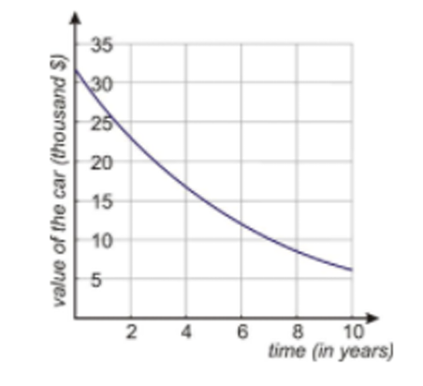
- When a new car is bought its value immediately begins to decrease. This is called depreciation and can be modeled by an exponential function, $f(x)=b^{x}$

What is the domain and range of this particular exponential decay function?

Does it have an asymptote? Explain what it means in the context of this problem.

What are the independent and dependent variables?
Why?
What are the intercepts and what do they represent?

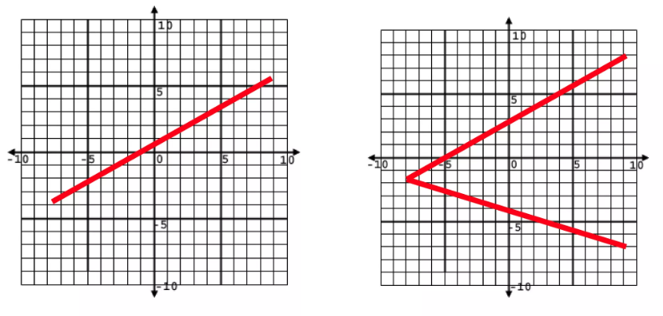
- Which one of these is not a function? Why?

- Julian, on the edge of sanity, launches his backpack up into the air from some stairs, which are 3 feet high. The graph below models the path of his backpack as it travels through the panhandle sky.
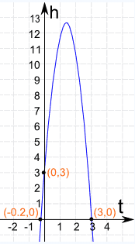
Analyze how long it takes his backpack to hit the ground.

- What does the domain represent?

- What does the range represent?

- What is a reasonable domain for the scenario?

- What is a reasonable range for the scenario?

- Does this function have an asymptote? If so, explain the relationship of the asymptote to its domain and range.

- What are the intercepts and what do they represent in this situation?

